第二章 死锁(2.4)

知识点：
https://chatgpt.com/g/g-p-6a4147b6a8088191bef869eb87bbe5c0-cao-zuo-xi-tong/c/6a6de103-7b38-83e8-99f4-3111526bb552

死锁的定义：
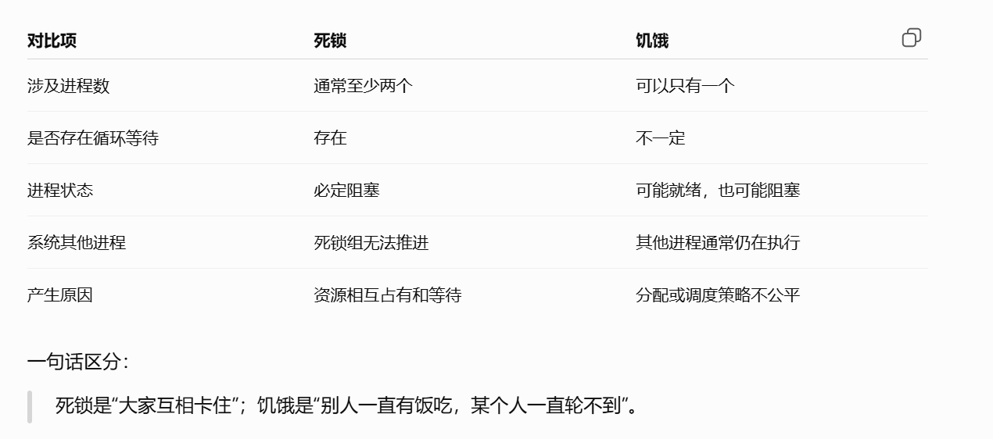

死锁产生的必要条件：
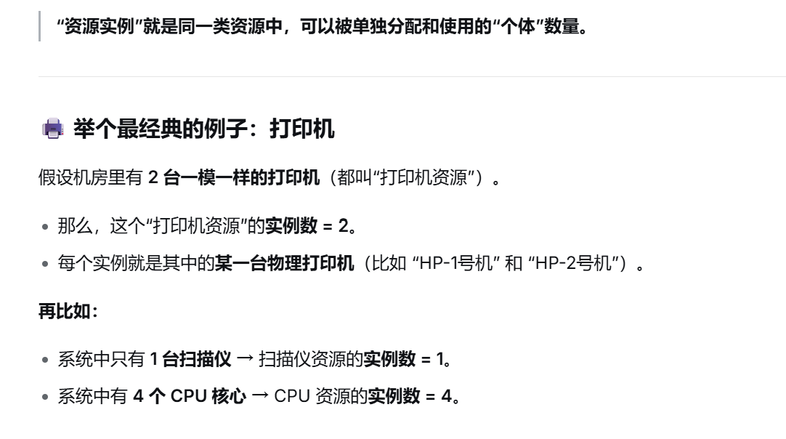

死锁的处理策略：
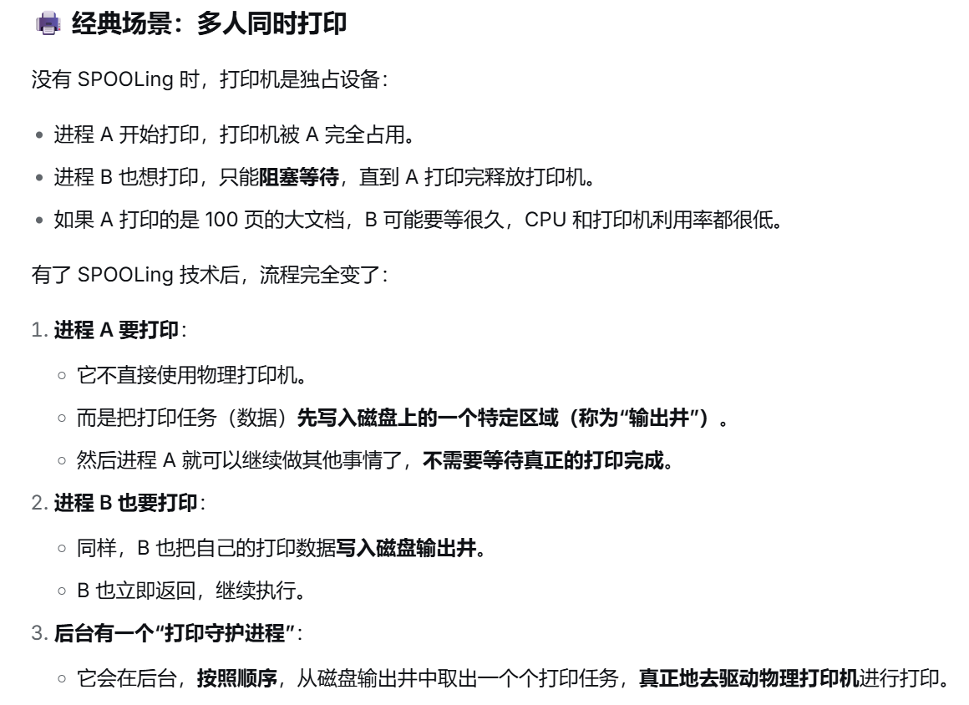

死锁的预防：
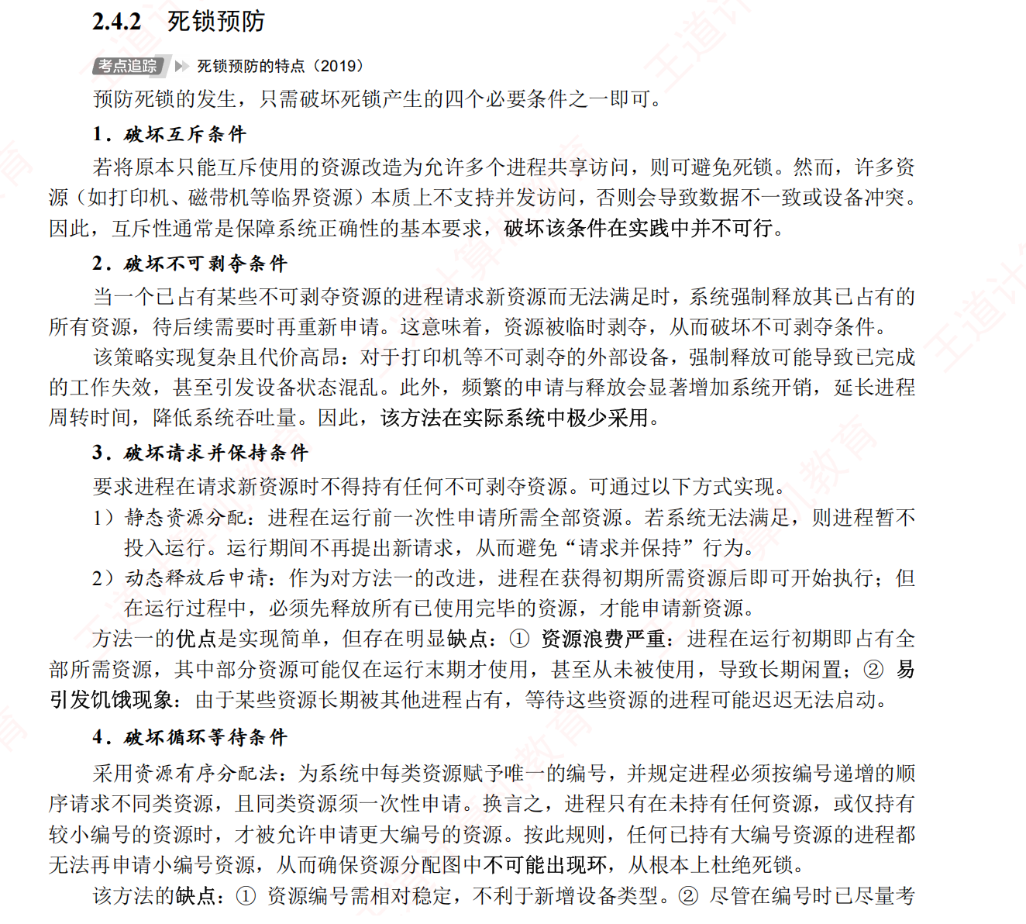

死锁的避免：
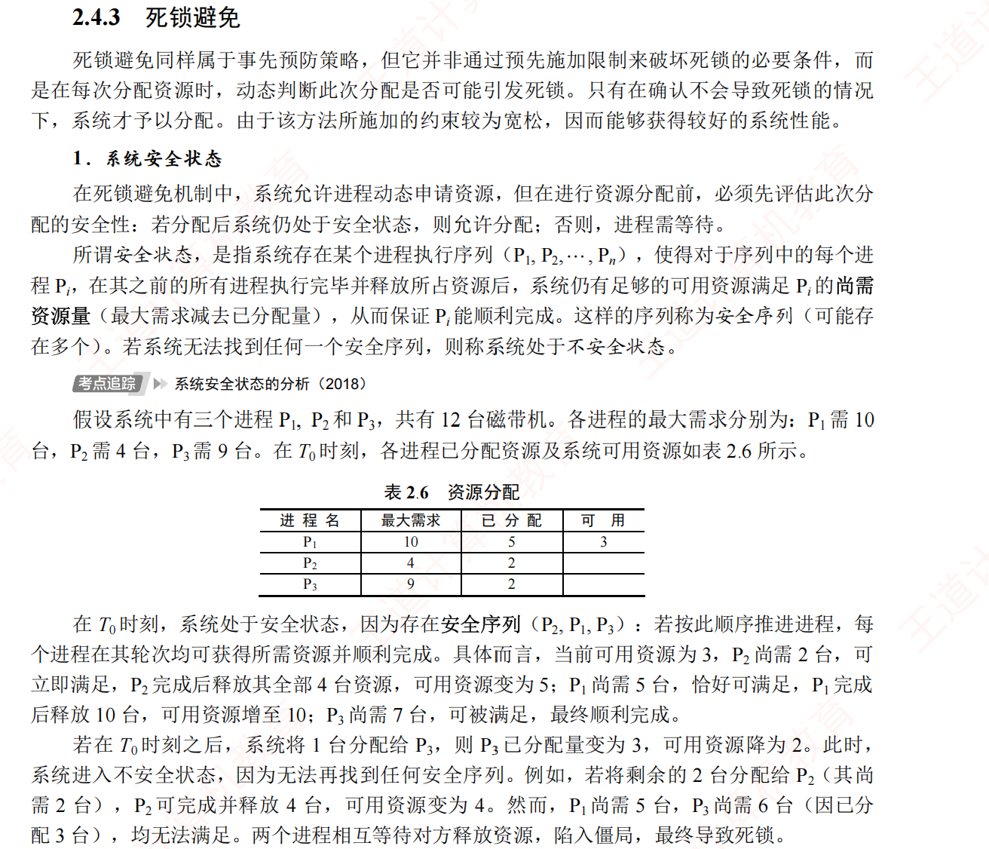

银行家算法避免死锁：
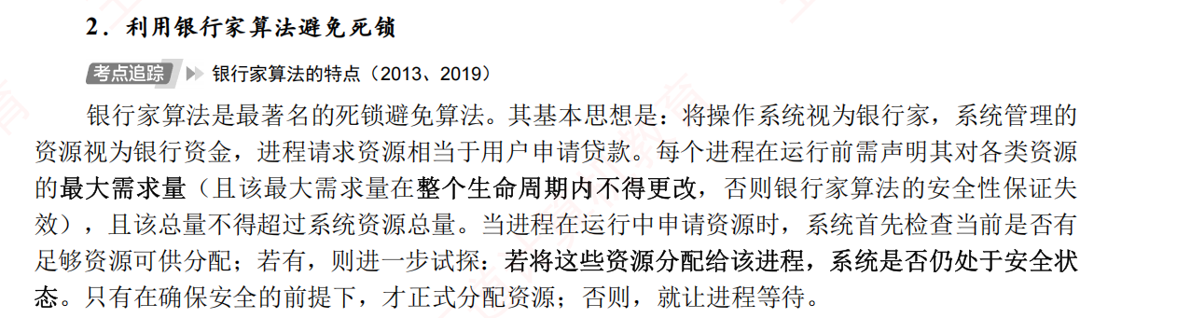
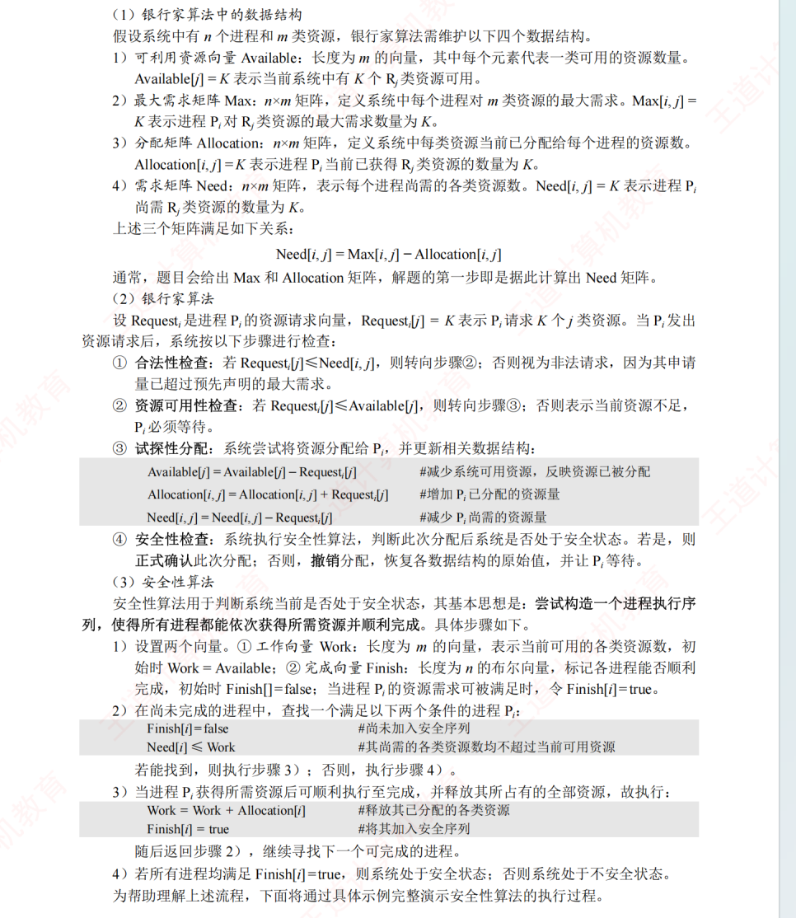
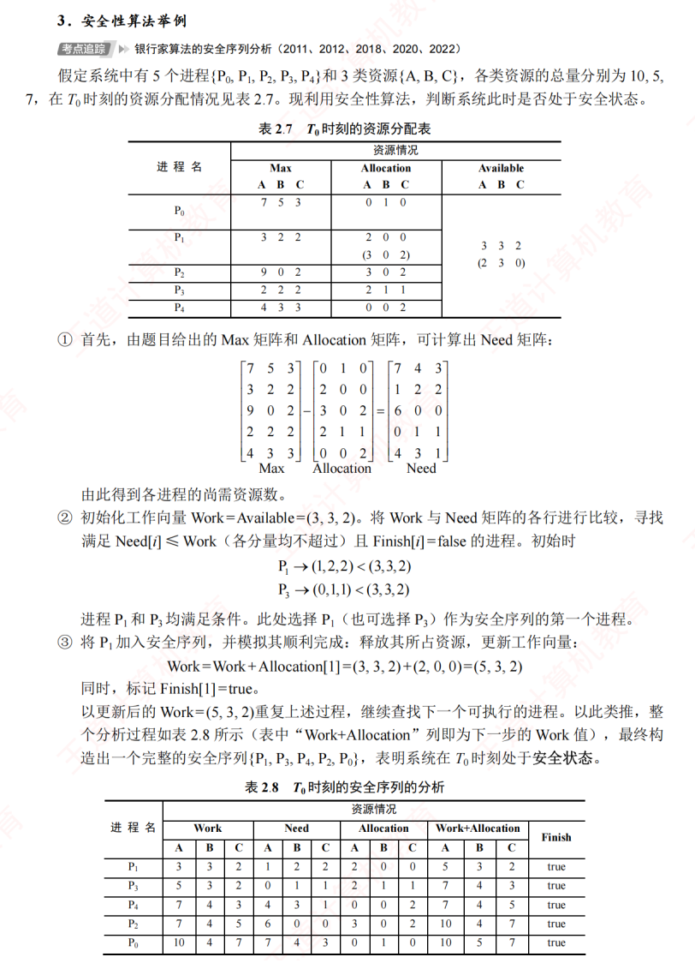
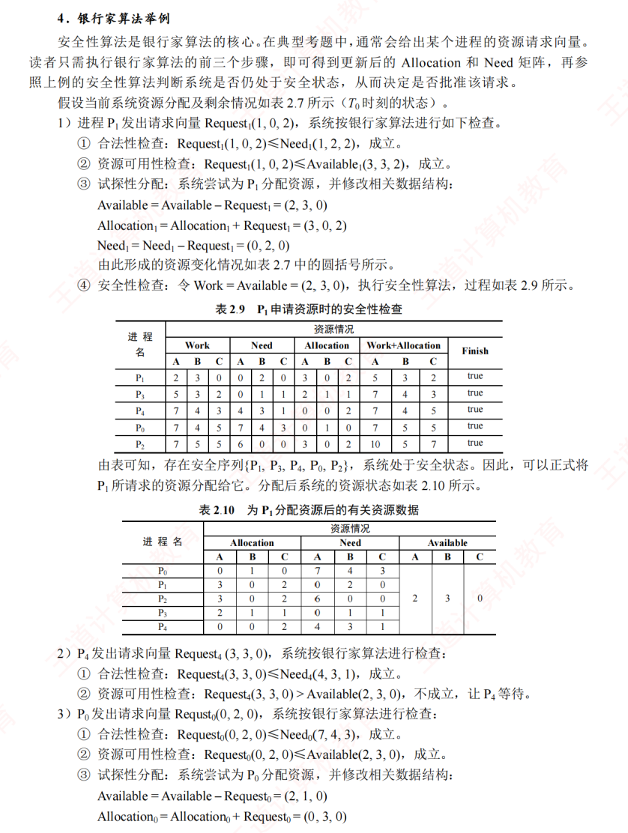
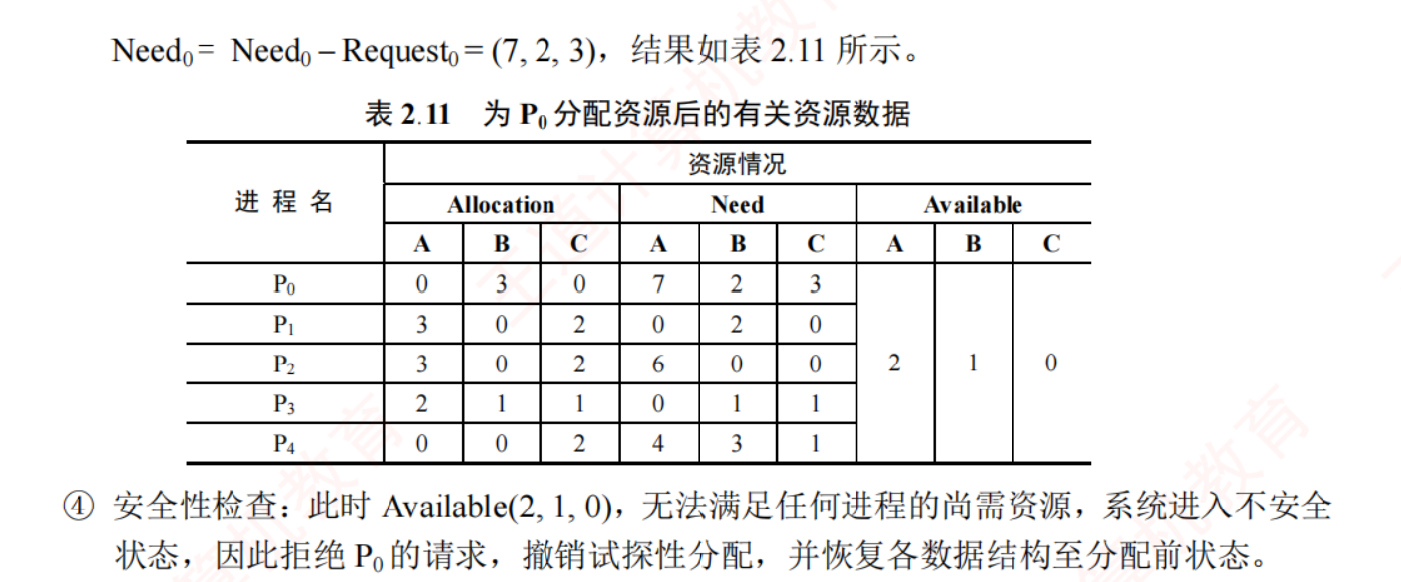

死锁检测与解除：
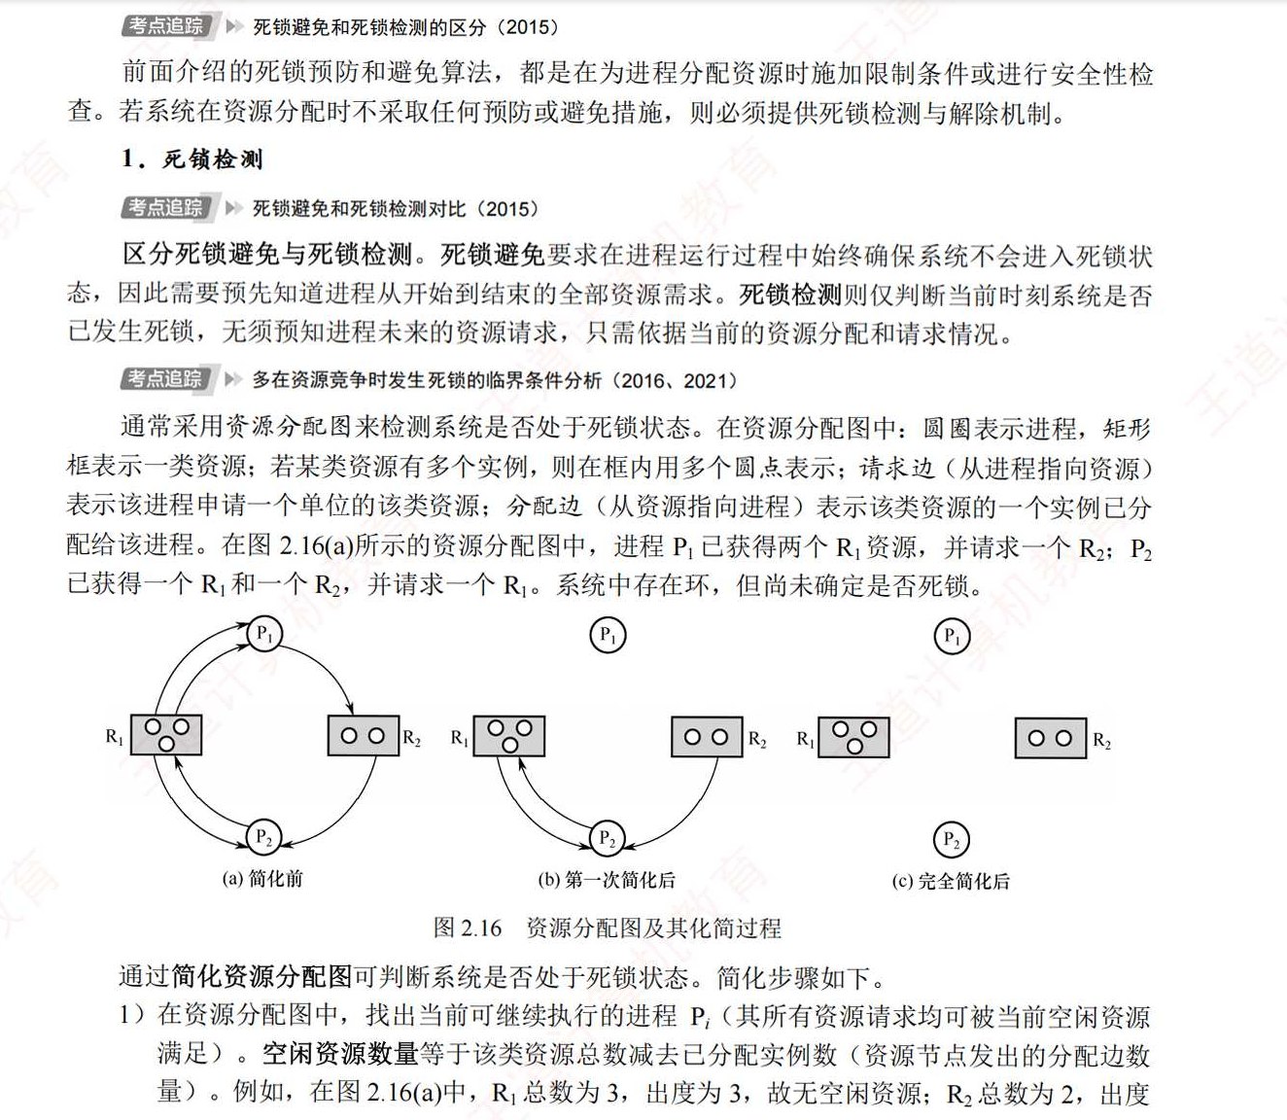
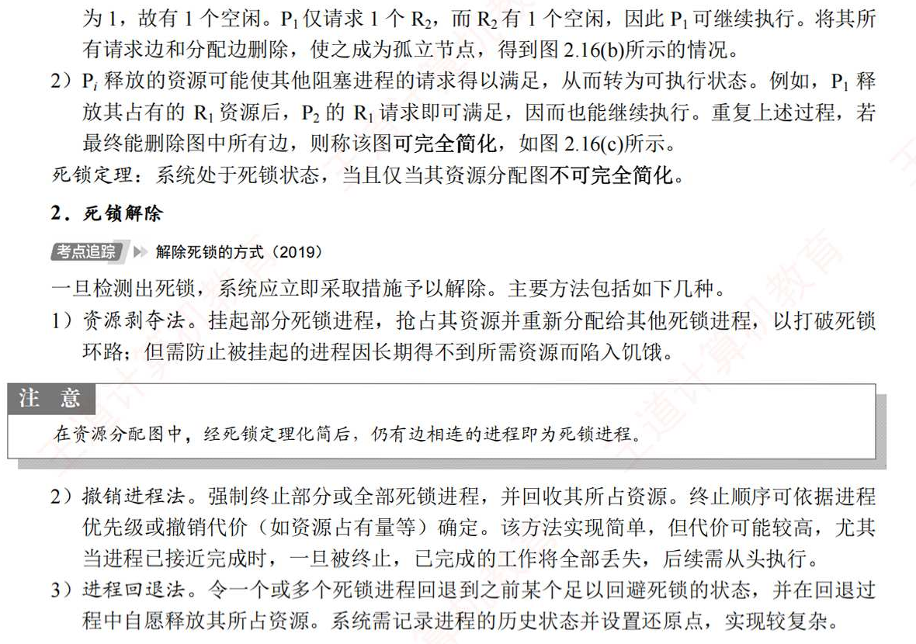
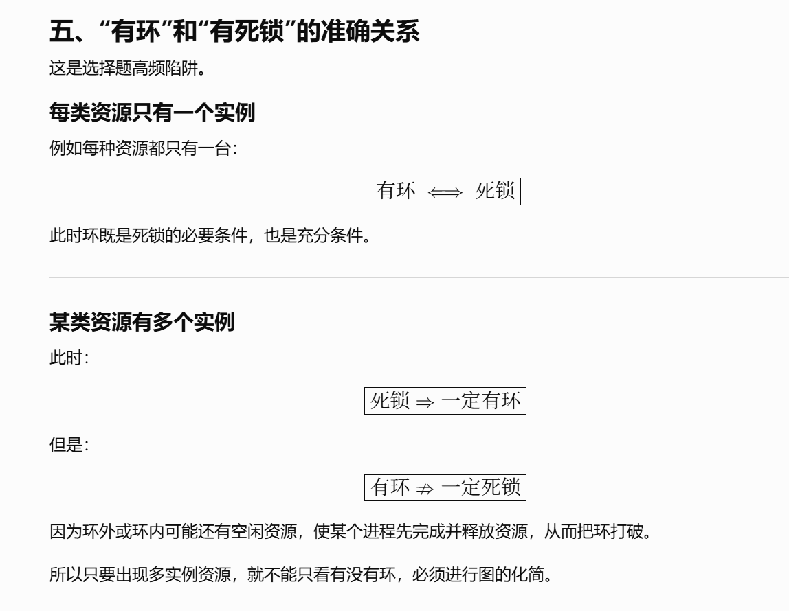
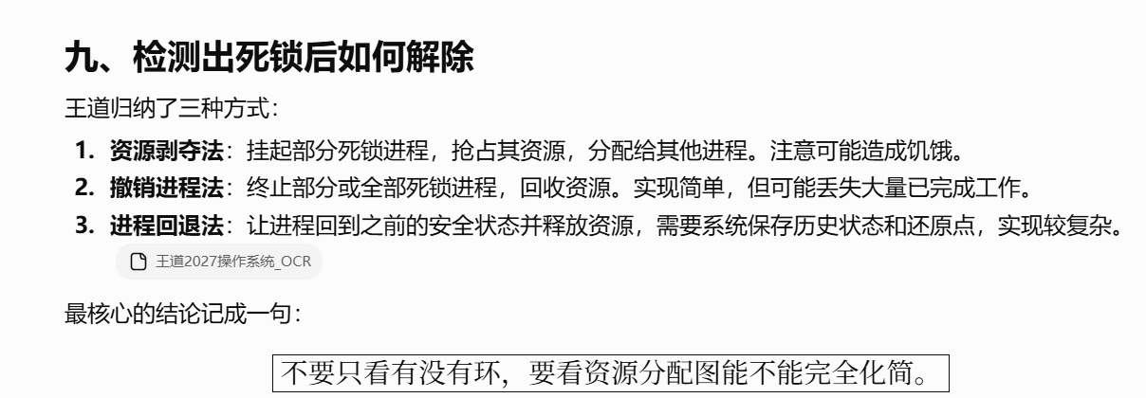
https://chatgpt.com/g/g-p-6a4147b6a8088191bef869eb87bbe5c0-cao-zuo-xi-tong/c/6a6ffb51-d96c-83ee-b4f0-8d6582823f15

概念：

资源静态分配策略：
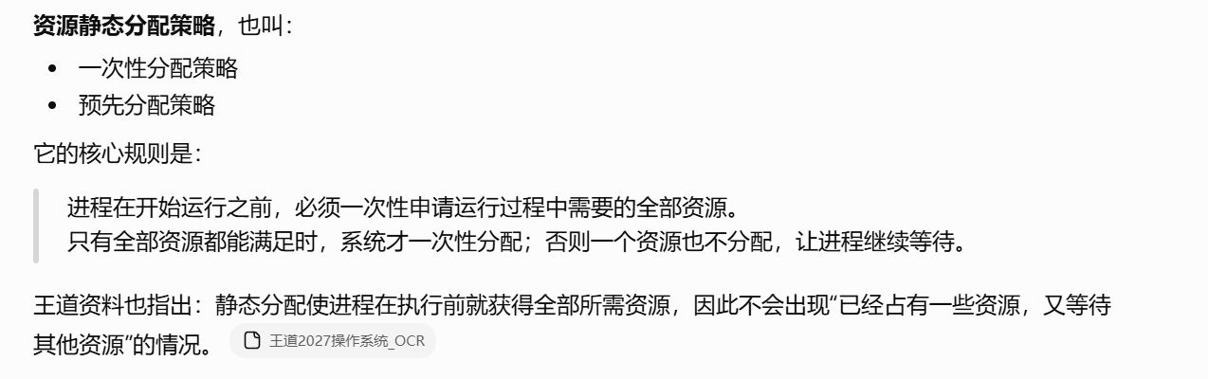
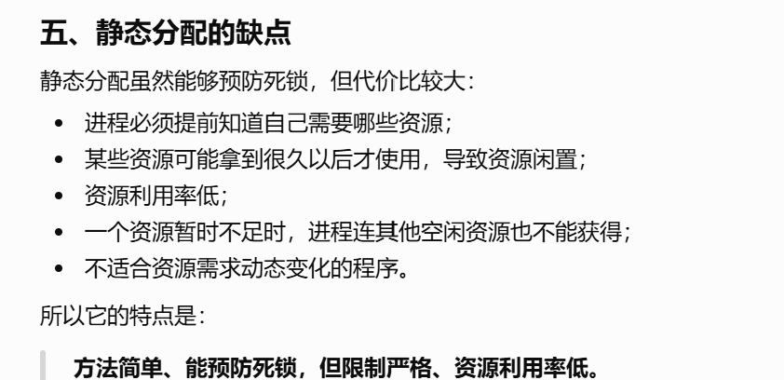

死锁的避免与预防：
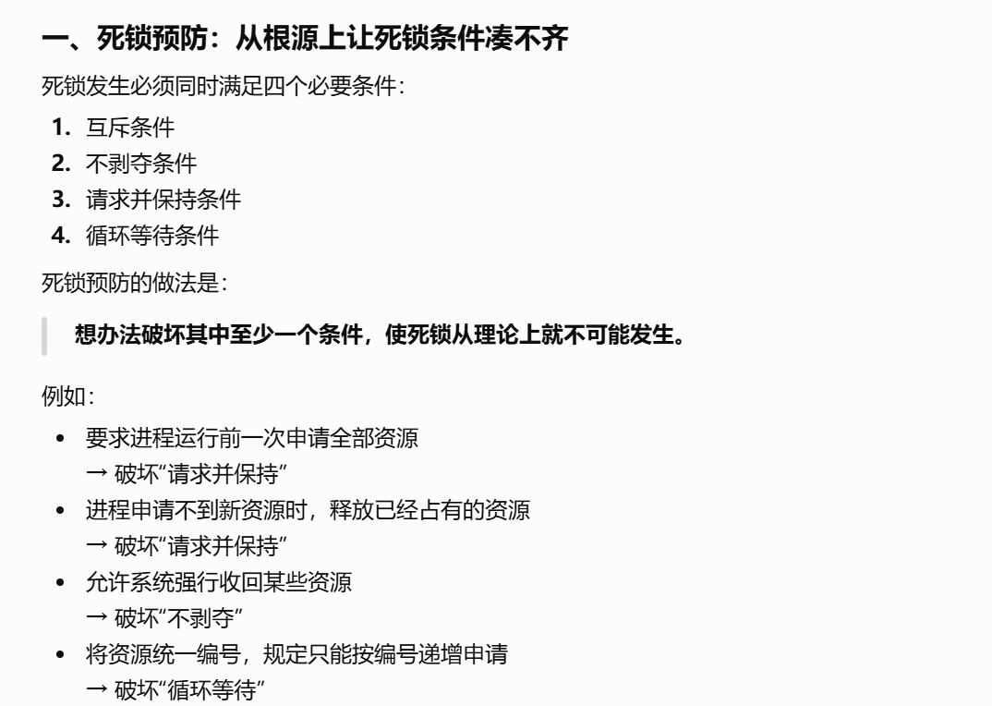
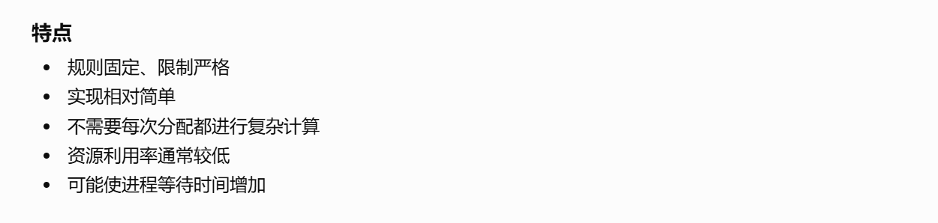
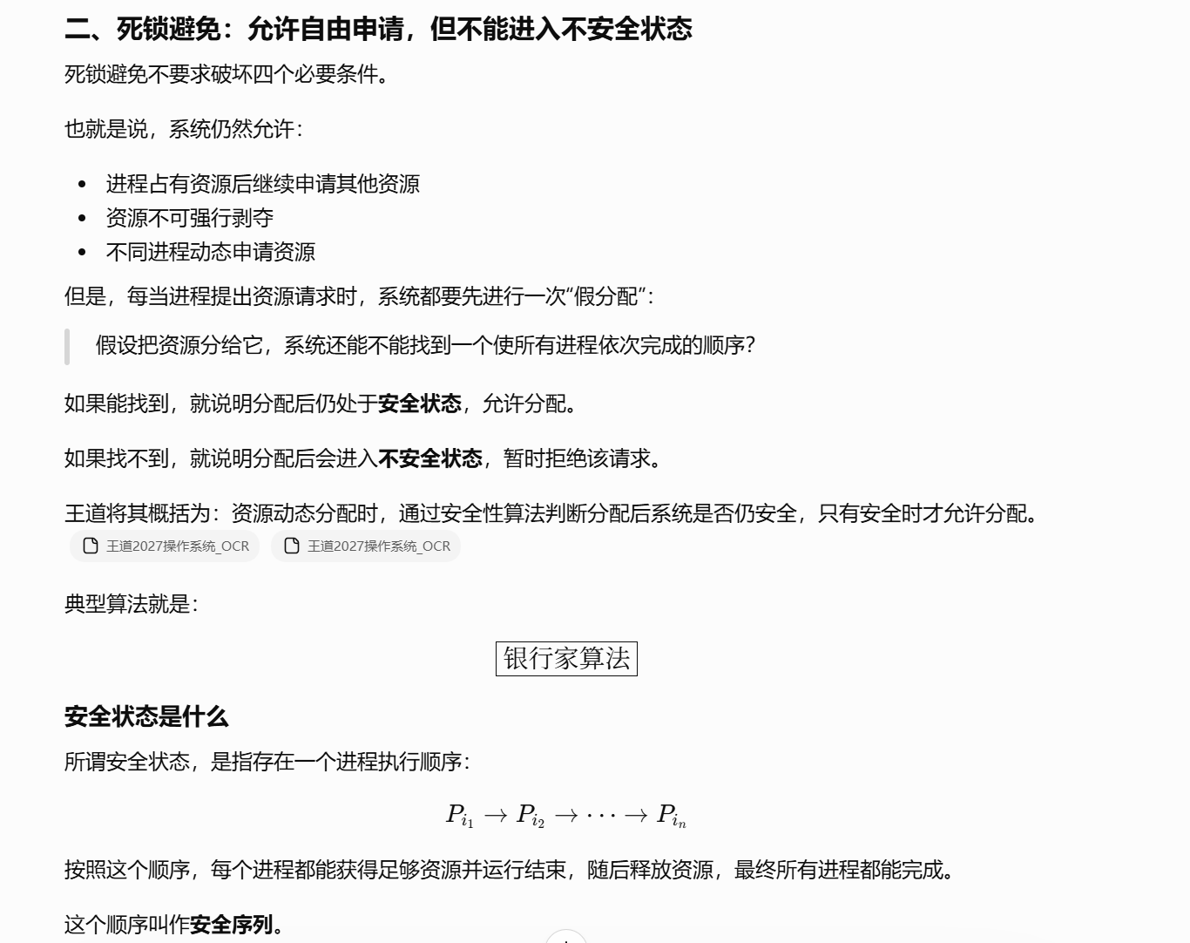
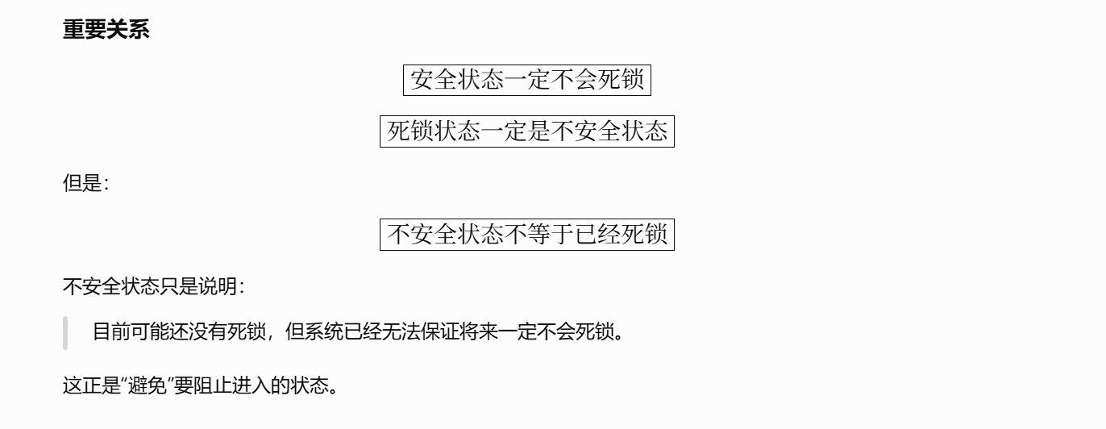
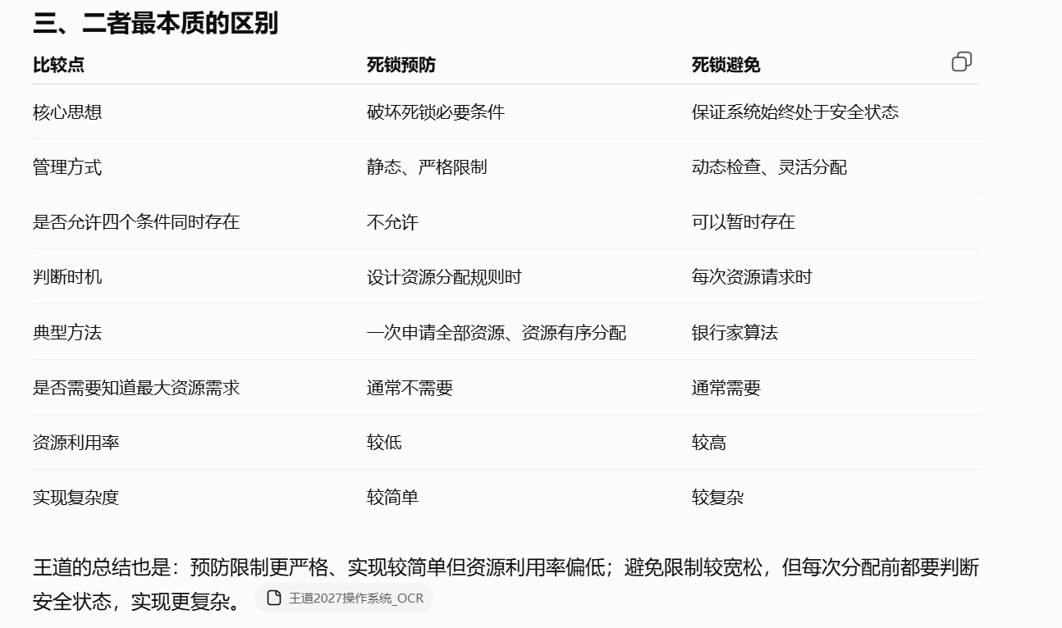
https://chatgpt.com/g/g-p-6a4147b6a8088191bef869eb87bbe5c0-cao-zuo-xi-tong/c/6a6ff64e-c99c-83ee-8aad-791e8df52a84
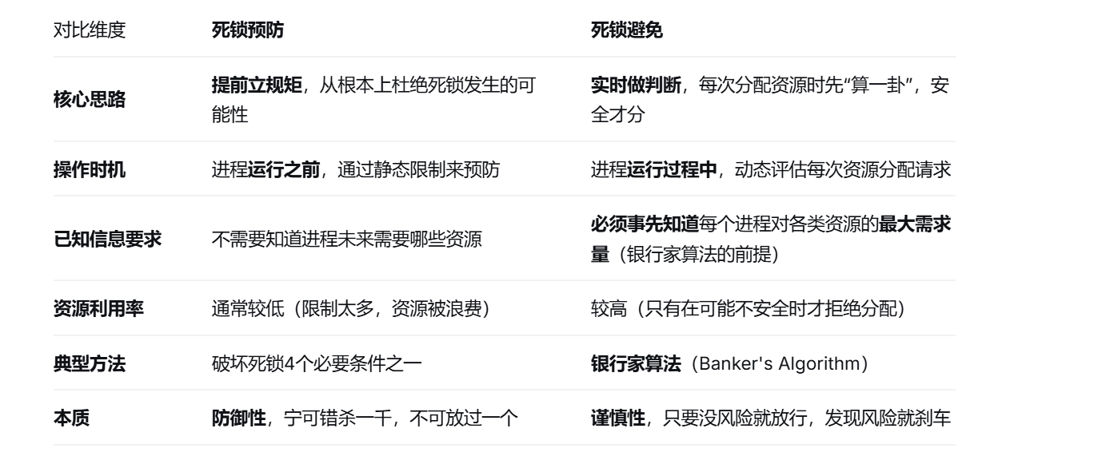

题：

题1：
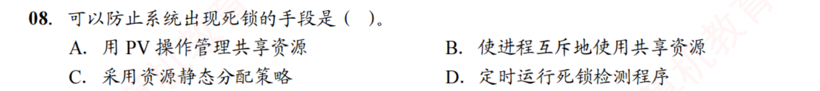
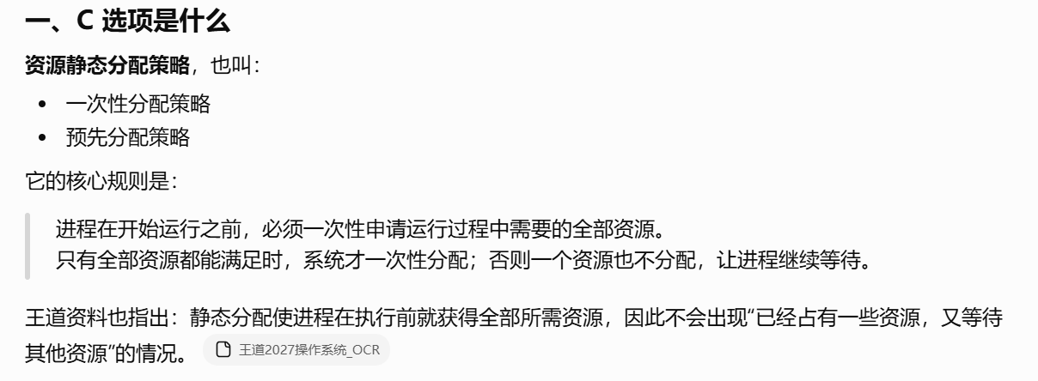
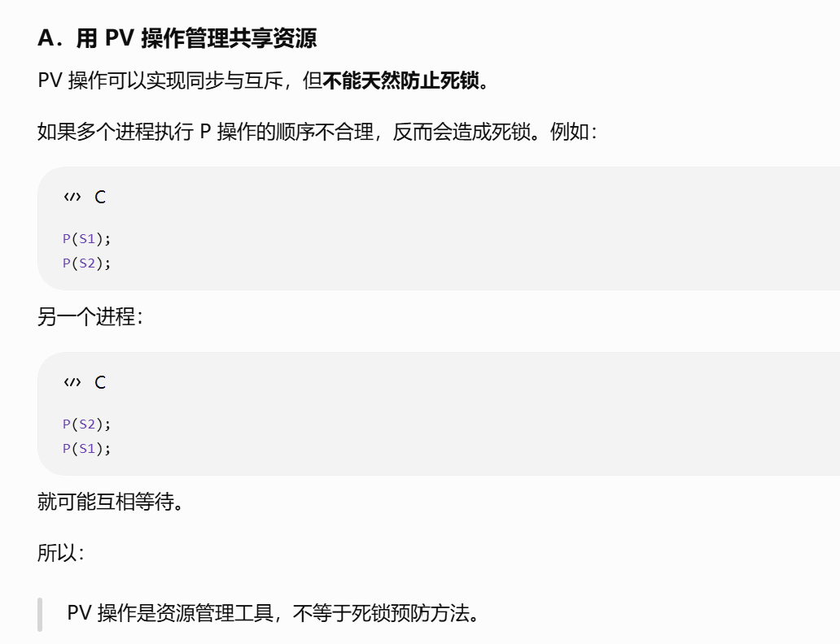

题2：
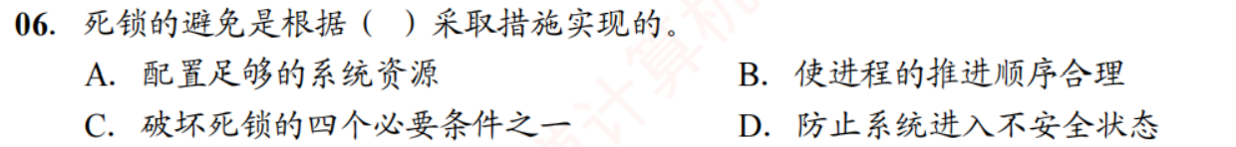
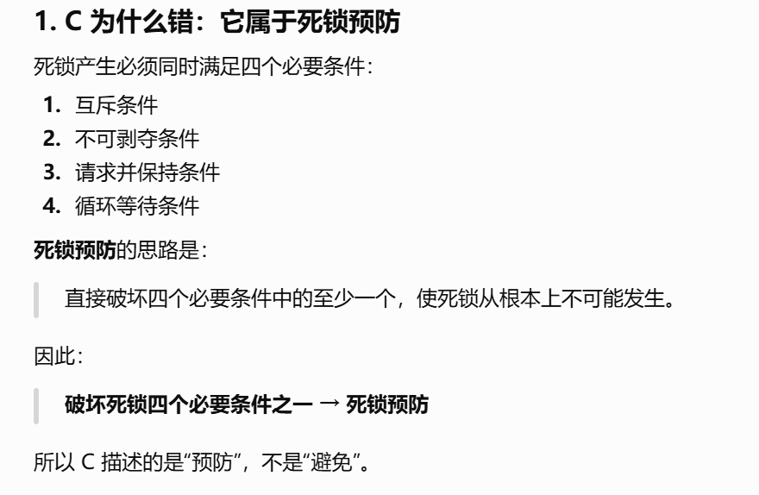
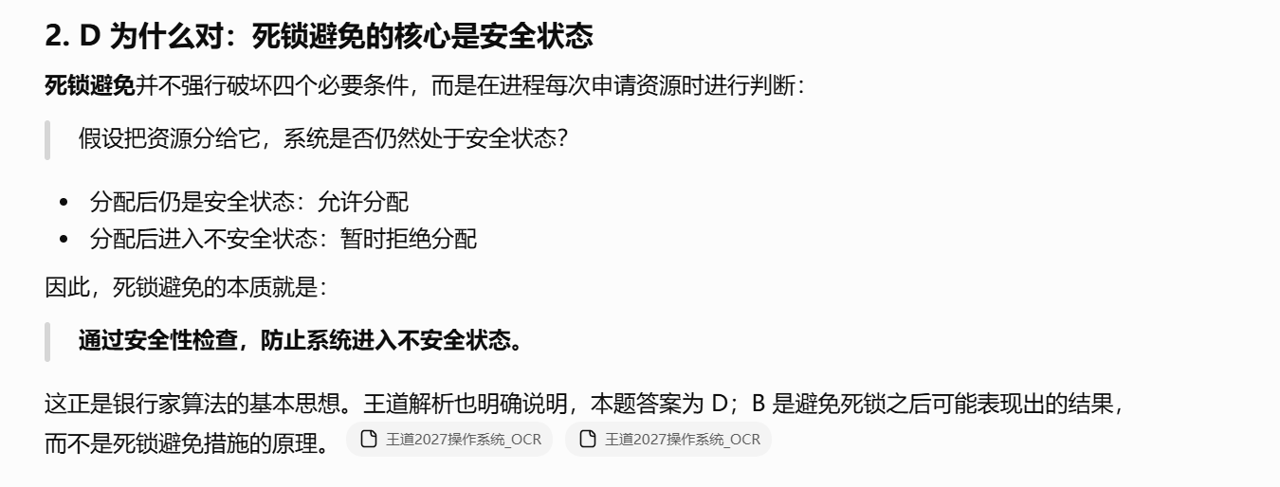
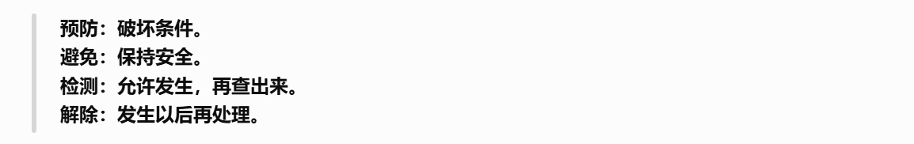
https://chatgpt.com/g/g-p-6a4147b6a8088191bef869eb87bbe5c0-cao-zuo-xi-tong/c/6a6def89-db8c-83ee-975f-574141f2cc0e

题3：
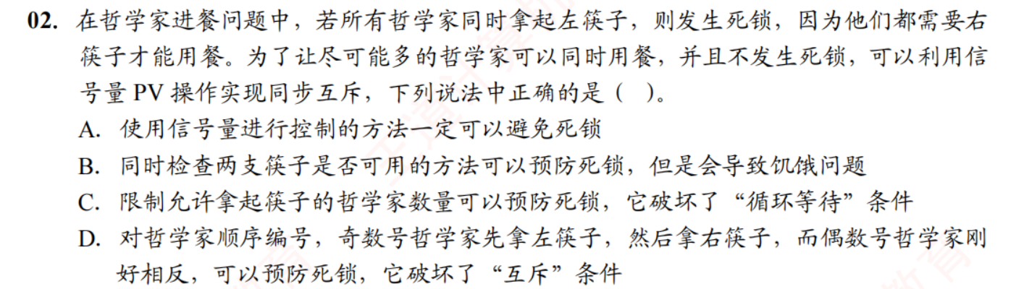
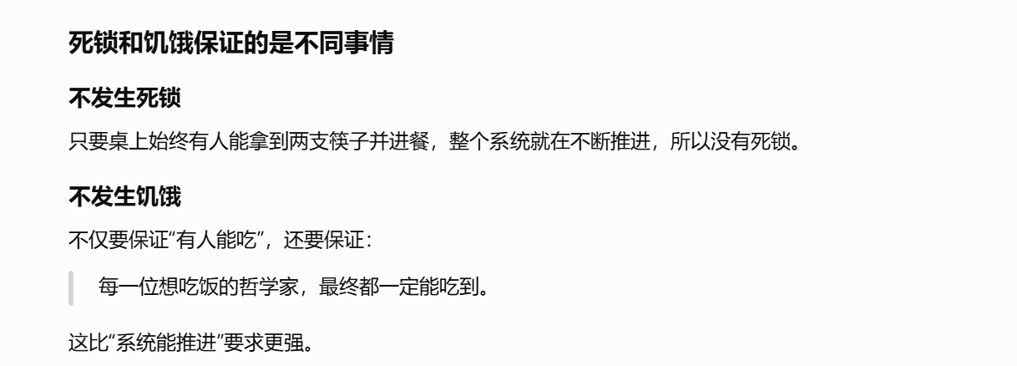

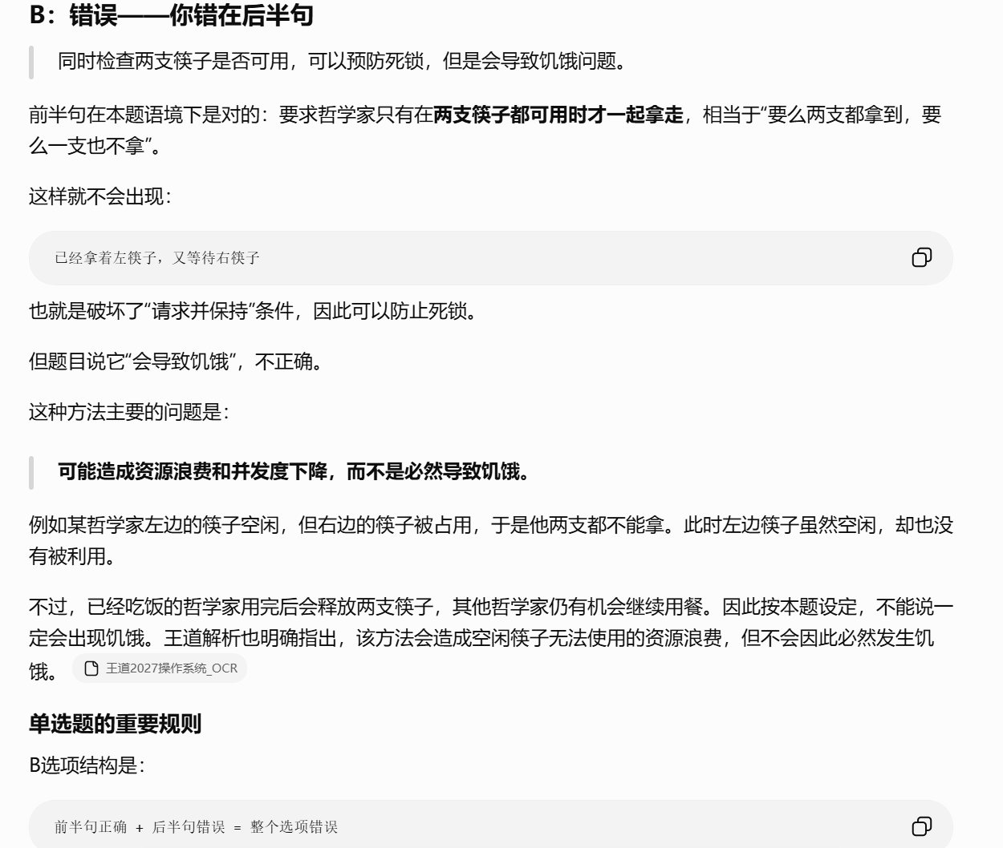
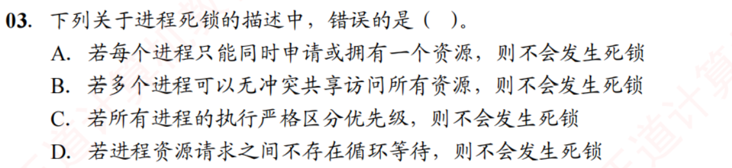
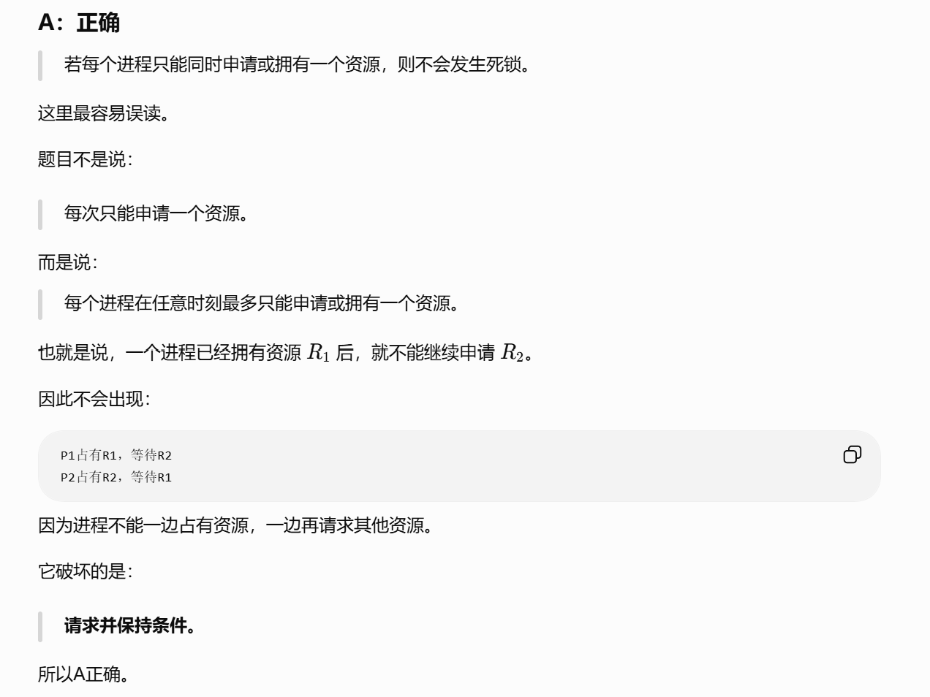
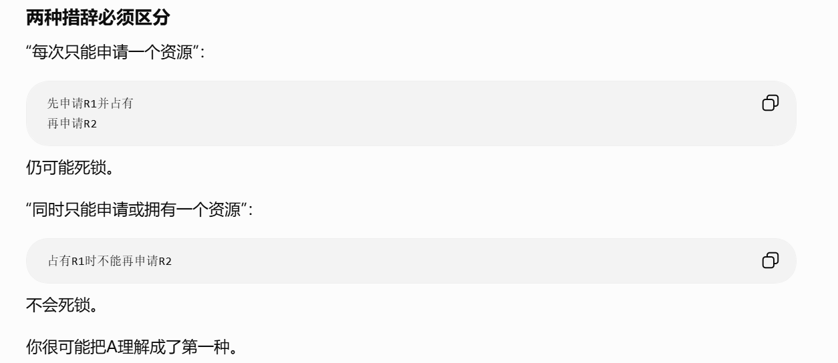
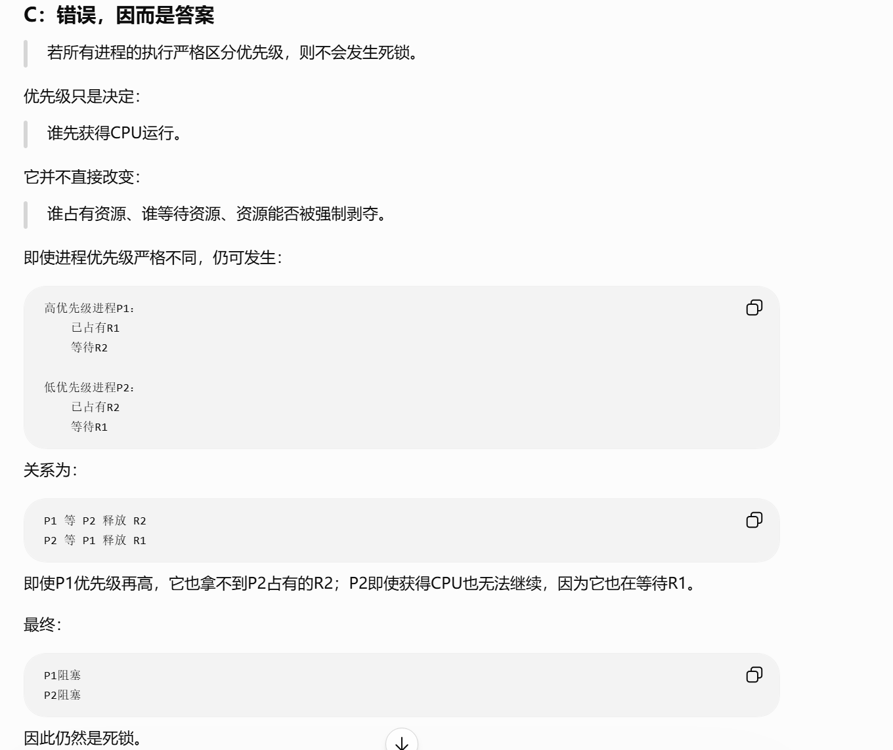
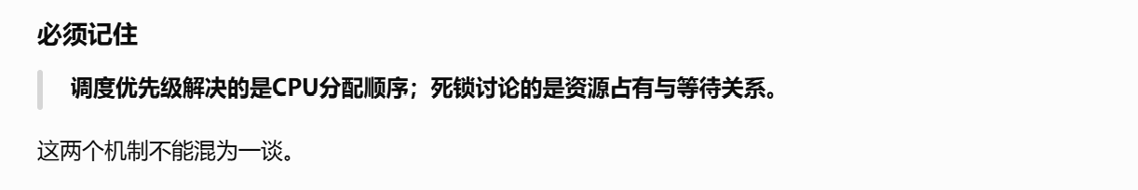
https://chatgpt.com/g/g-p-6a4147b6a8088191bef869eb87bbe5c0-cao-zuo-xi-tong/c/6a6defca-c0a8-83ee-98e5-43673a39a693

题4：
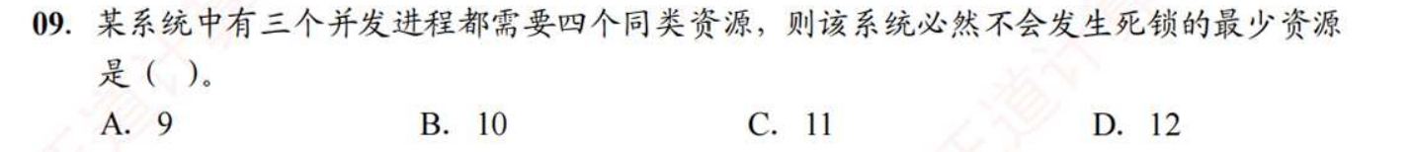
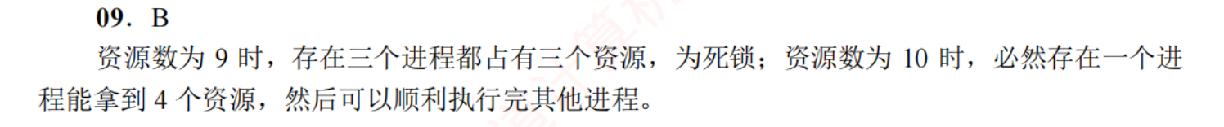
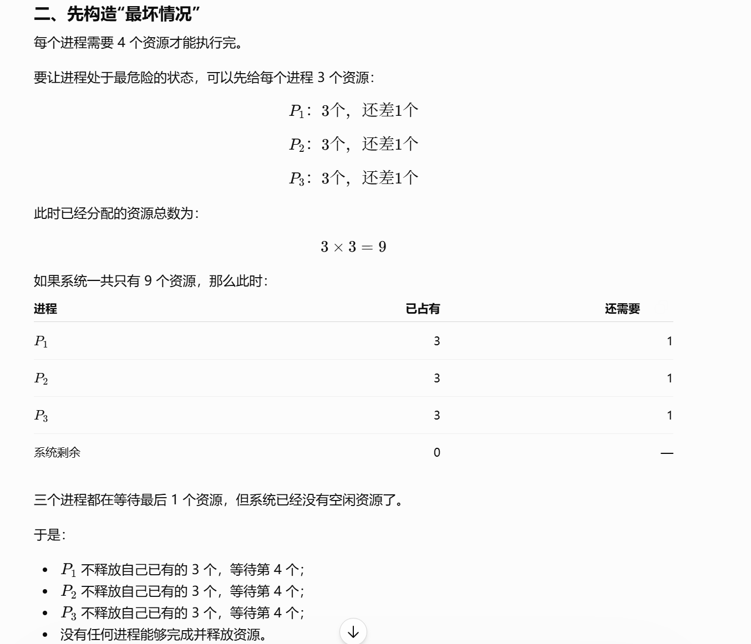
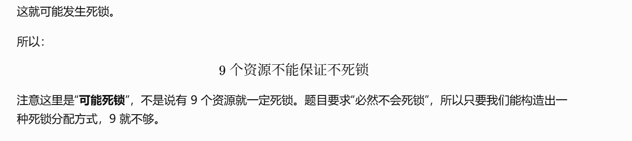

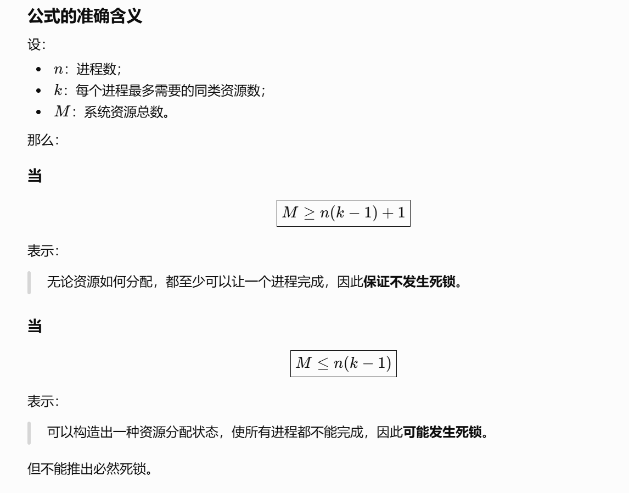
https://chatgpt.com/g/g-p-6a4147b6a8088191bef869eb87bbe5c0-cao-zuo-xi-tong/c/6a6f4a50-fa2c-83e8-8e97-5e34092f3884

题5：
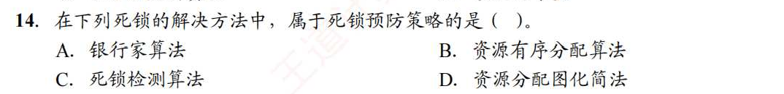
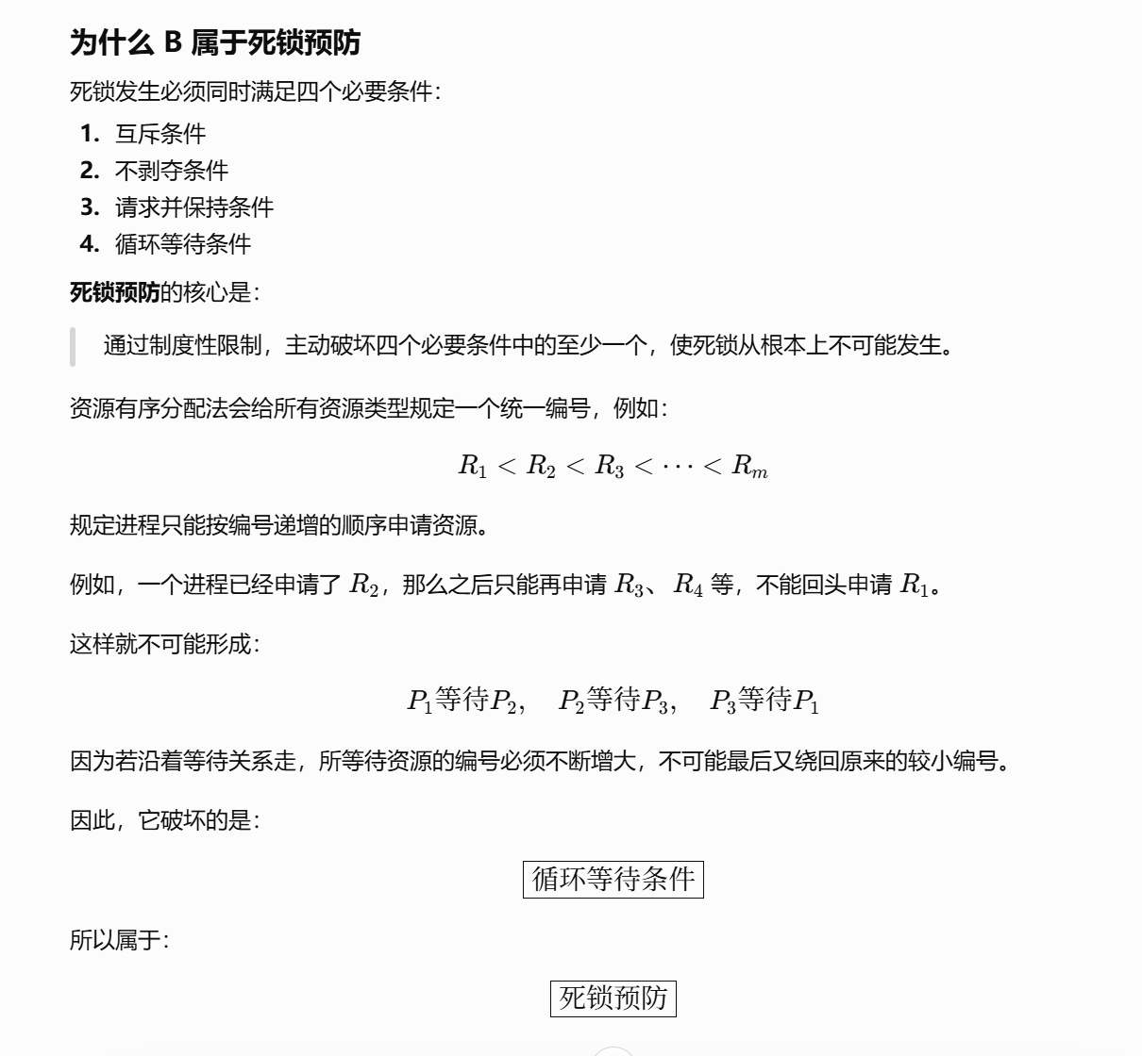
https://chatgpt.com/g/g-p-6a4147b6a8088191bef869eb87bbe5c0-cao-zuo-xi-tong/c/6a6ff7ca-fb58-83ee-b295-e36175b83aa9

题6：
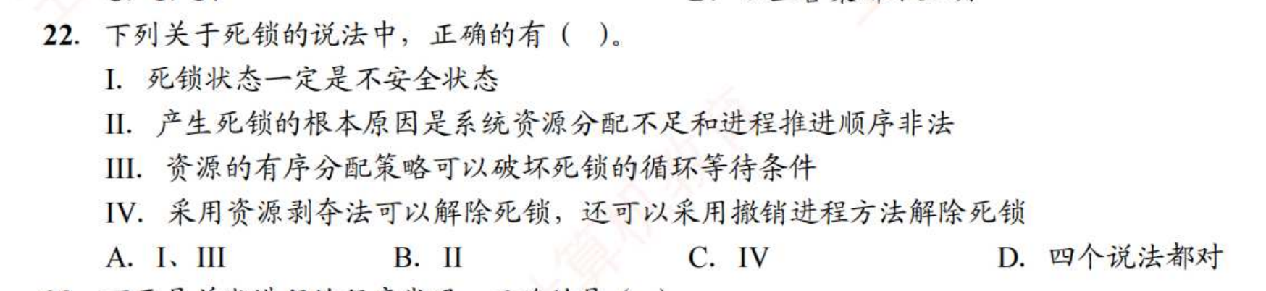
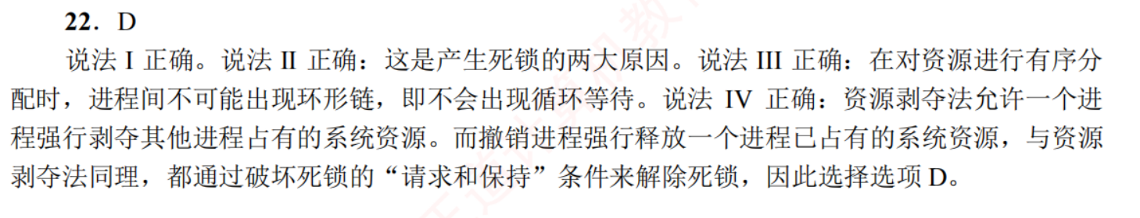

题7：
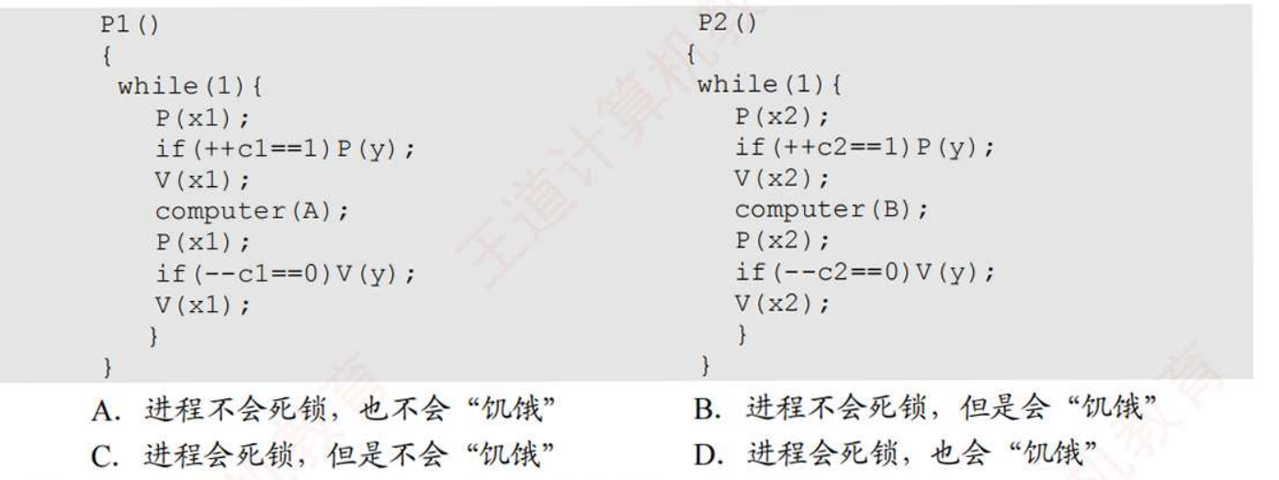
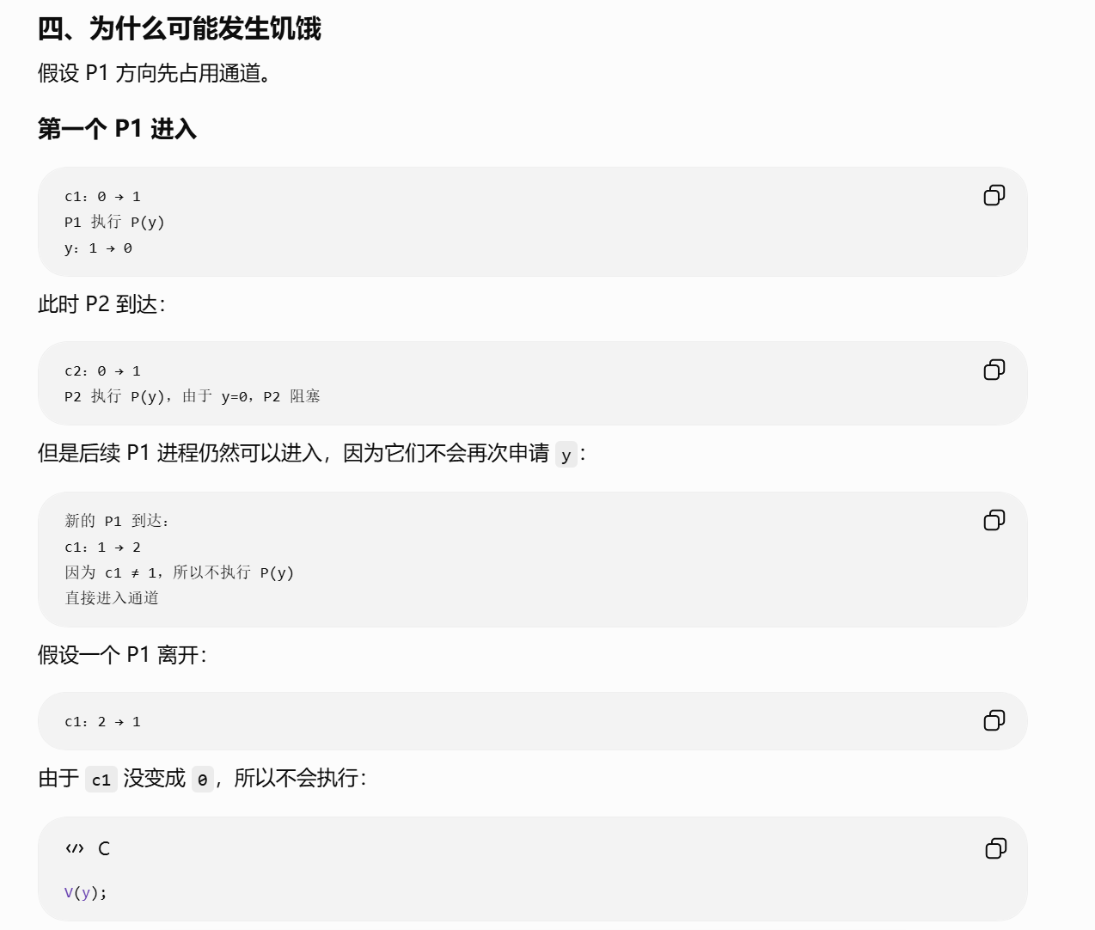
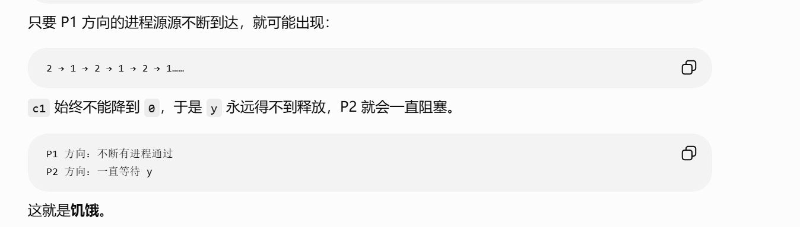
https://chatgpt.com/g/g-p-6a4147b6a8088191bef869eb87bbe5c0-cao-zuo-xi-tong/c/6a6fff39-5d8c-83ee-8d9a-55b7602f6f92

题8：
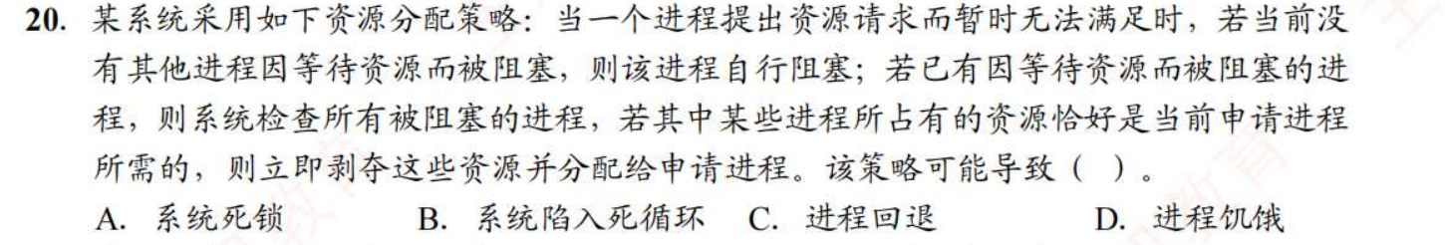
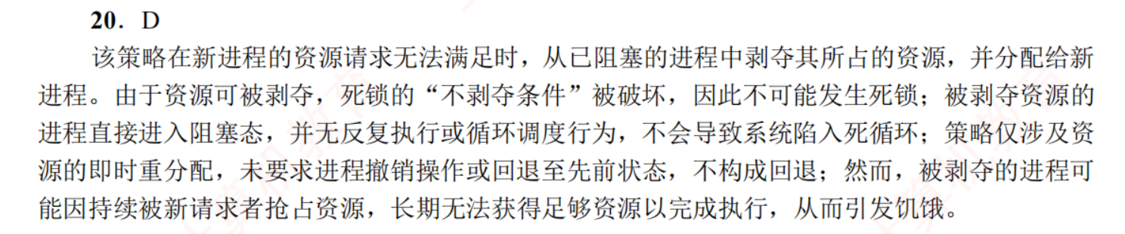

题9：
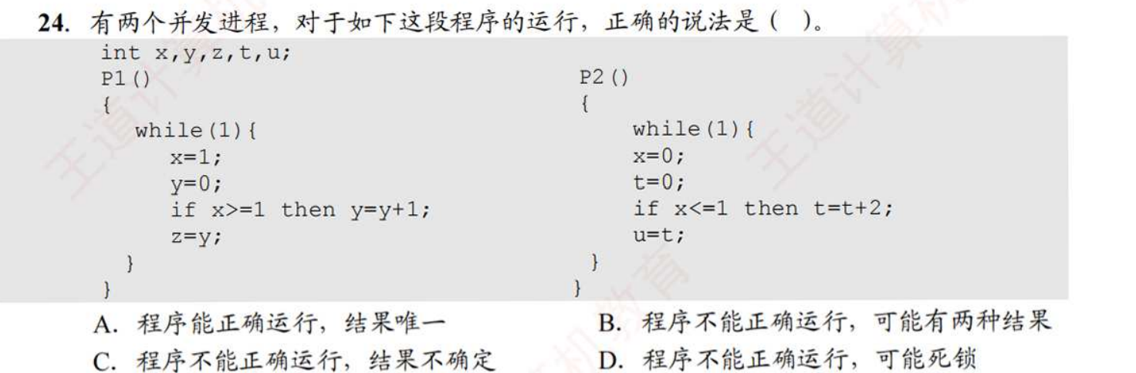
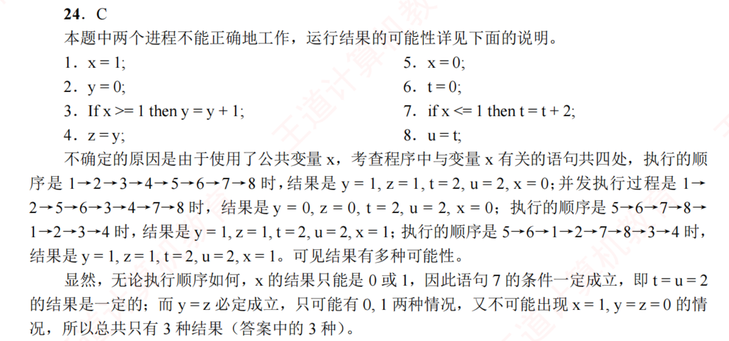
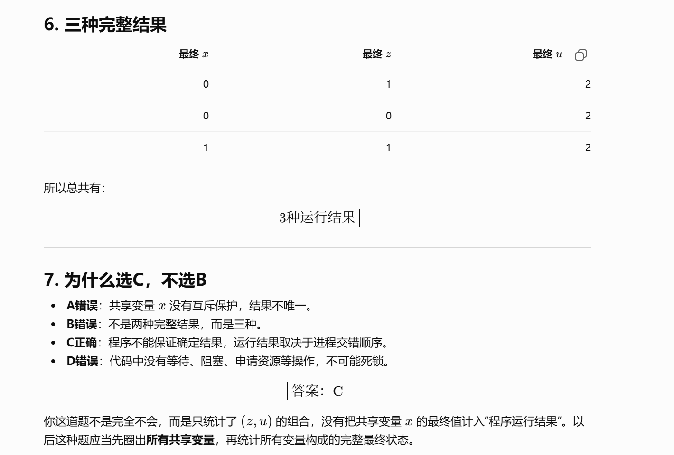
https://chatgpt.com/g/g-p-6a4147b6a8088191bef869eb87bbe5c0-cao-zuo-xi-tong/c/6a7005b5-a09c-83ee-968d-019b8456572c

题10：
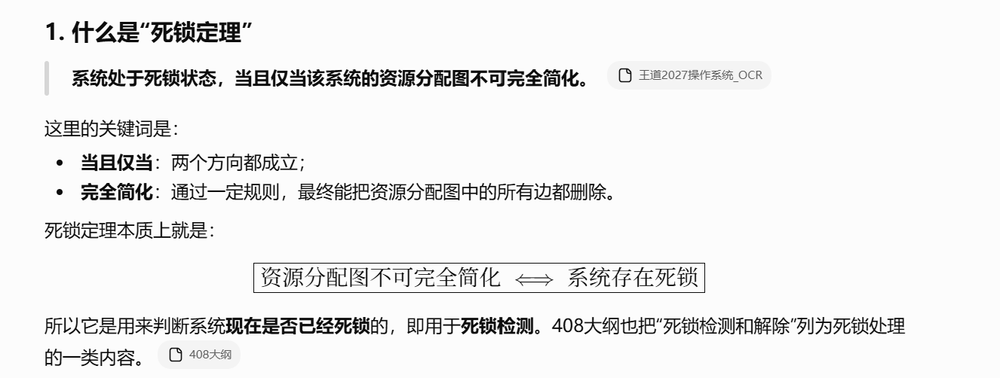
https://chatgpt.com/g/g-p-6a4147b6a8088191bef869eb87bbe5c0-cao-zuo-xi-tong/c/6a700611-d004-83e8-8ea0-9e8a0039ba9c

题11：
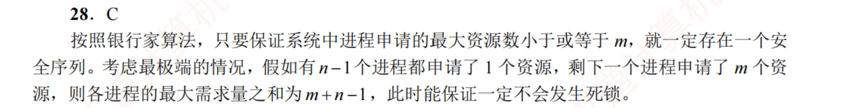
大于小于号写反了导致做错

题12：
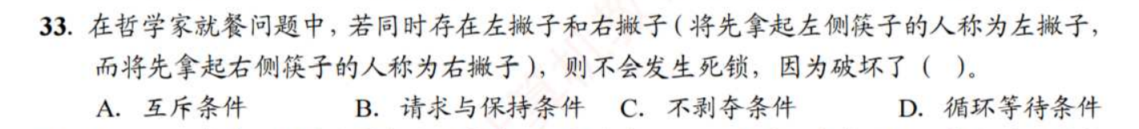
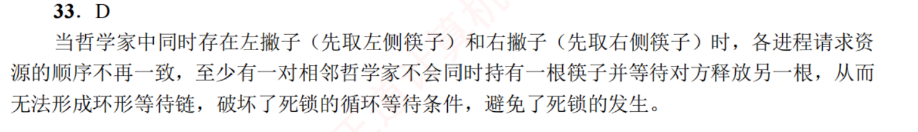

题13：
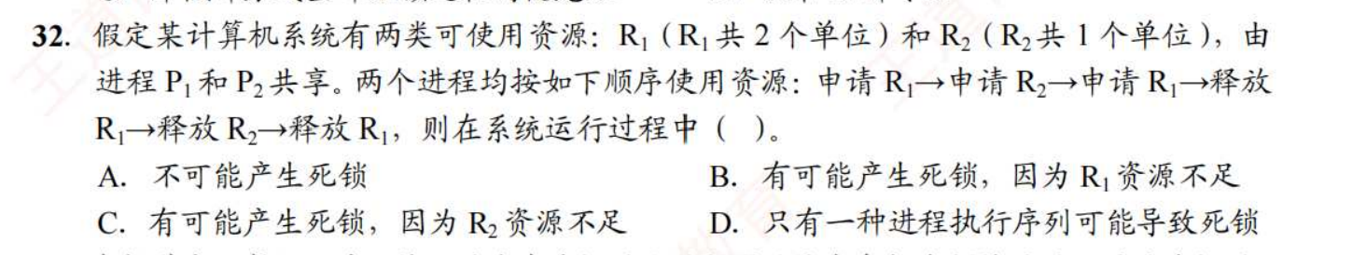
https://chatgpt.com/g/g-p-6a4147b6a8088191bef869eb87bbe5c0-cao-zuo-xi-tong/c/6a700cdb-9994-83ee-b81b-bde09bb1ae18

题14：
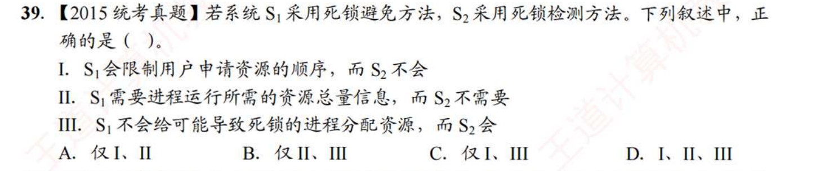
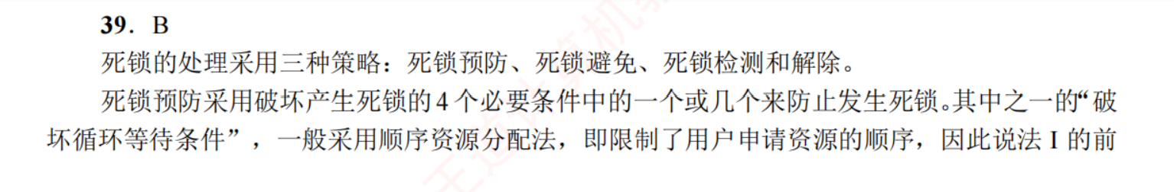
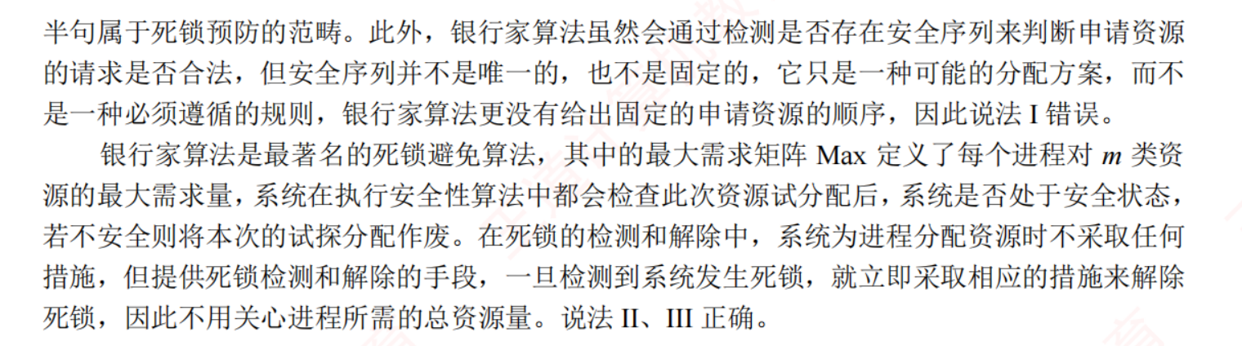
https://chatgpt.com/g/g-p-6a4147b6a8088191bef869eb87bbe5c0-cao-zuo-xi-tong/c/6a701cf0-8d68-83ee-a351-317400c9031c

题15：
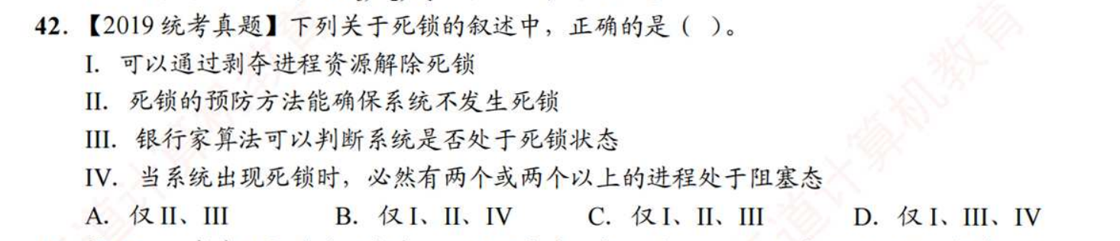
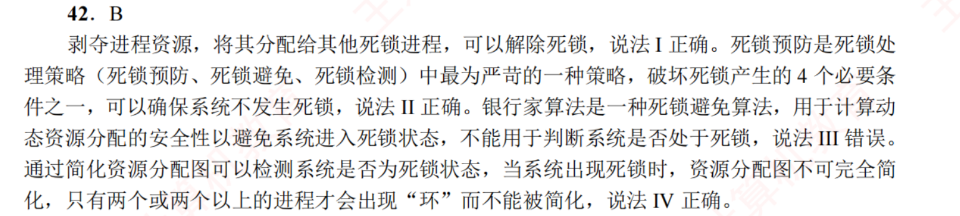
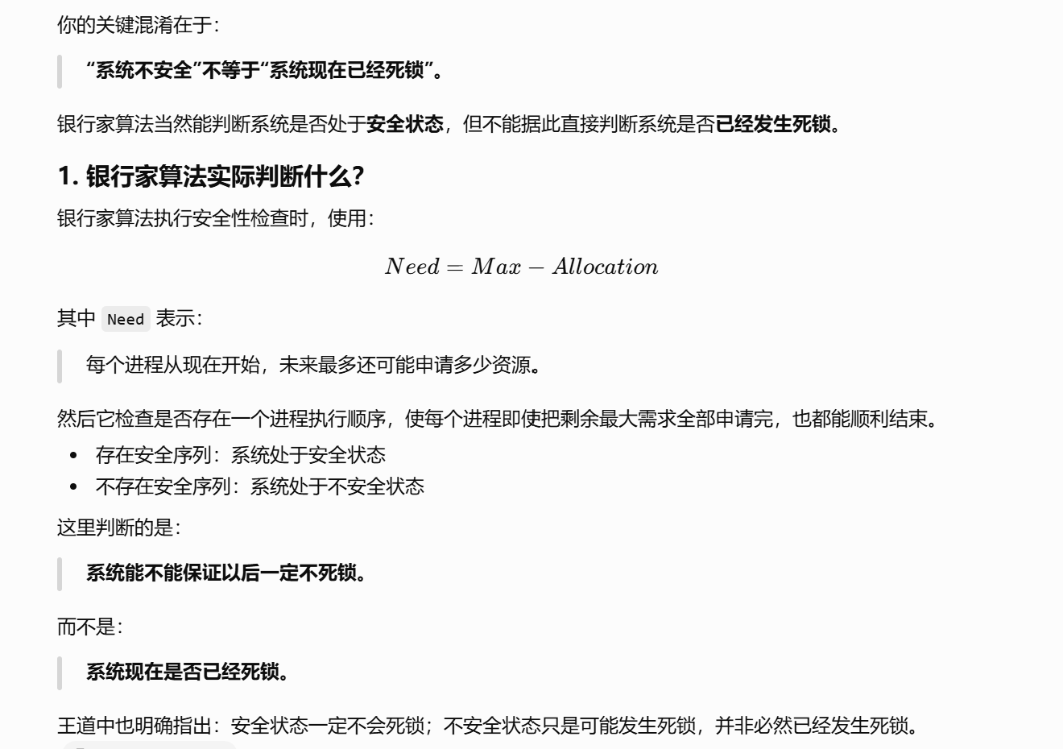
https://chatgpt.com/g/g-p-6a4147b6a8088191bef869eb87bbe5c0-cao-zuo-xi-tong/c/6a701e03-062c-83e8-b663-b2bd983afc8d

题16：
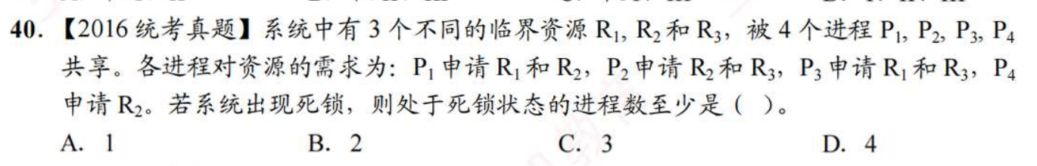
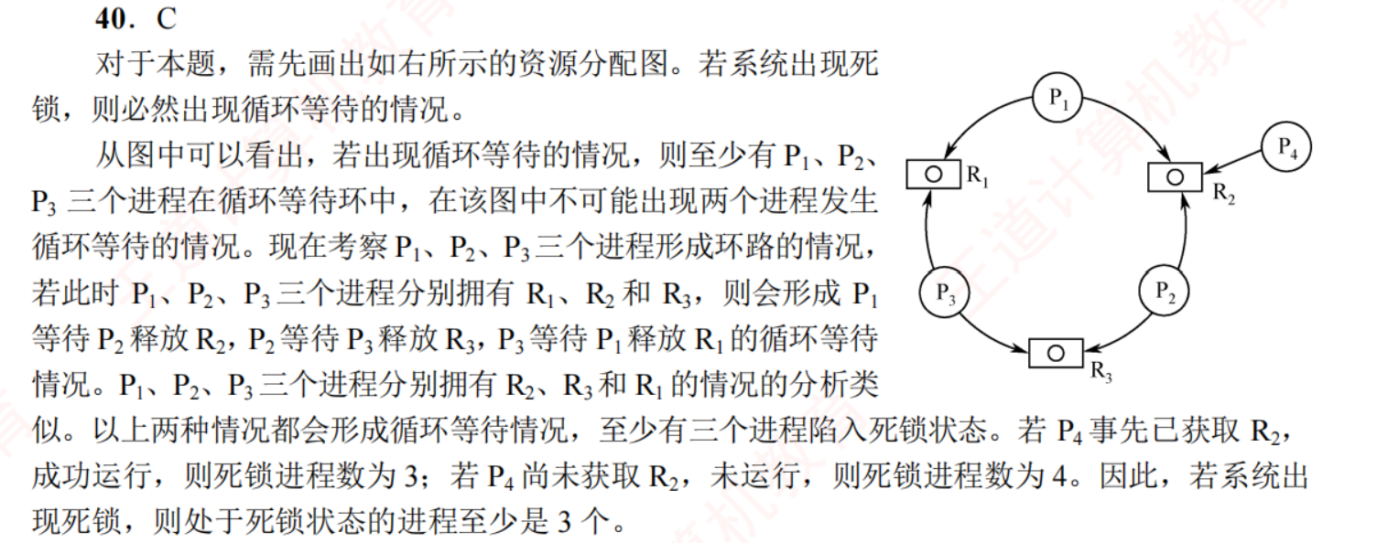
https://chatgpt.com/g/g-p-6a4147b6a8088191bef869eb87bbe5c0-cao-zuo-xi-tong/c/6a702c48-2820-83e8-889c-f19e344e9e3c
|（注：部分内容可能由 AI 生成）

